Goal Setting and Ministry Alignment

I. Goal Setting

- The General Electric S.M.A.R.T. System
1. Introduction
The research shows that “focused” (goal oriented) people:
- Work harder
- Get tasks done more quickly
- Stay married longer
- Have deeper networks of friends
- Earn more
- Don’t second guess themselves
- Are seen as more disciplined
- Are seen as good leaders

BUT
The emotional satisfaction that comes from (1) deciding and (2) clearing tasks from a list creates several problems.
- They may focus on easy tasks at the expense of important tasks
- They make hasty decisions
- They are less likely to reconsider unwise decisions
And in a leader these can lead to harmful behaviors that are contrary to good pastoral leadership and deadly to effective turnaround leadership:
“The instinct for decisiveness is great, until it’s not.”
– Charles Duhigg, Smarter Faster Better
- Authoritarian impulses
- Closed-mindedness
- Preference for conflict over cooperation
2. Cautions
- When you set goals (or make decisions) be mindful of whether the goal (or decision) you’re settling on makes you feel good at some level.
“Avoid mood maintenance!”
- If you are prone to be more concerned about being productive in the moment than you are about doing the right things over the long haul, you need a system to counterbalance that tendency. (More below)

3. Implementing the S.M.A.R.T. system

In the 1940s General Electric began a decades long process of developing a corporate goal-setting system that eventually became a model that is followed by organizations around the world. In this model, goals must be provably within reach and described in a way that suggests a concrete plan.
The process of making a goal specific and proving it is achievable involves figuring out the steps it requires. Putting it on a timeline creates discipline that mere aspiration cannot.

 | Item | Detail
S | Specific
M | Measurable
A | Actionable
R | Realistic
T | Timeline
Sample SMART Goals
 | Item | Detail
S | Specific | I will run a half marathon
M | Measurable | Finish! I ran a half marathon
A | Achievable | - I’ve done it before  - My physician gave his approval  - I have a coach to help
R | Realistic | - I have the time to train  - I’m willing to get up at 4 a.m. to run  - I want to change my weight
T | Timeline | December 15, 2016 Halualoa Half  - Run 35 miles in May  - Run 40 miles in June  - Run 45 miles in July  - Run 50 miles in August  - Run 1@15+1@20+20 miles in September  - Run 2@15+25 miles in October  - Run 40 miles in November  - Taper 1st two weeks December

You will have to train your leaders and volunteers to produce SMART goals for their ministries and events. Those who tend to be “big picture” types with little patience for details may resist, but if you frame this as a request for their help – so that you can manage more effectively – they should in time work with you. (If they won’t there’s an alignment problem that needs to be addressed, see below).
“Making yourself break a goal into its SMART components is the difference between hoping something comes true and figuring out how to do it.”
- Charles Duhigg,
Smarter Faster Better
Continually ask your team
- “Is this concrete?”
- “What are the specifics?”
- “Is this realistic?”
- “Show me your timeline?”
- Stretch Goals
1. A problem with SMART goals
SMART goals by themselves will not insure that your ministry accomplishes anything significant. If you or the majority of your team members spend most of the time working on insignificant goals, you will remain stalled on the plateau.
- People who crave the sense of accomplishment
- Those who are afraid to risk striving for big goals
  - Shallow ego needs
  - Your organization penalizes failure
- Those who don’t connect their goals with the organization’s mission
2. Stretch goals as a solution
“A stretch is a concept that would have produced smirks, if not laughter, in the G E of three or four years ago, because it essentially means using dreams to set business targets-with no real idea of how to get there. If you do know how to get there-it’s not a stretch target.”
- Jack Welch, Letter to G.E. Shareholders, 1993
a. Purpose of stretch goals
The purpose of insisting that your church or ministry teams commit to stretch goals is to shake them out of complacency and promote new ways of thinking.
- “Eliminate the debt on our mortgage in one year”
- “Provide a Backyard Bible Club for every child in South Tucson.”
- “Sell our property and meet in rented facilities to reach 5,000 homes in that new subdivision.”
- “Cancel worship services every 5th Sunday to send every member to serve in the community.”
b. Two caveats about stretch goals
1) Studies have shown that if a stretch goal is audacious, it can spark innovation.
2) It can also cause panic and convince people that success is impossible
There is a fine line between an ambition that spurs innovation, creativity and energy and one that destroys morale.
- Integrate STRETCH goals with the SMART system
Stretch goals push us out of the “tried and true” and motivate us to greater achievements. The SMART system help us break big goals down into a series of realistic, short-term objectives. Integrating the two puts the impossible within reach.
Research in the world of sports, business, and self-management demonstrate that experience with methodical planning, when applied to new and daunting challenges, enables people to break the BHAGs into a series of manageable objectives that together make it possible.
- Develop a list of your biggest dreams.
(“Teach Old Testament at Jordan Evangelical Theological Seminary.”)
- Describe major objectives that at first glance seem impossible
(“Earn Ph.D. in Old Testament Language and Literature.”)
- Segment major objectives into smaller objectives
(“Enroll in seminary with program suited to my needs”)
(“Accumulate funds for education”)
(“Secure housing for family near seminary”)
- Break the smaller objectives into concrete steps
- Create a to-do lists that pairs stretch and SMART goals
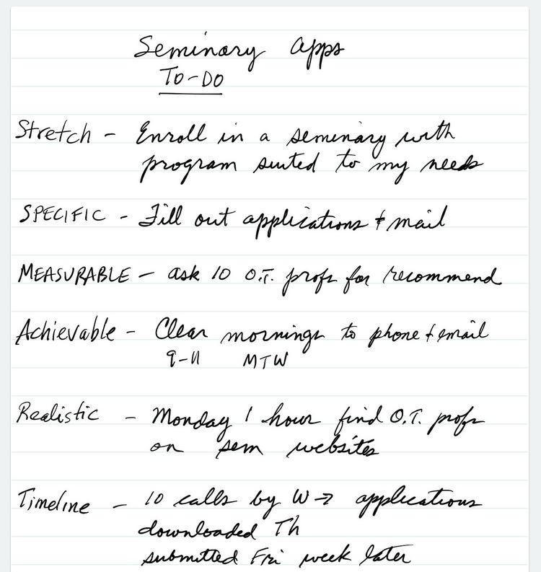

Those of you who are detail oriented won’t lose sight of the big picture, thereby avoiding the trap of using task lists to perform “mood maintenance.” Those of you who are big picture oriented won’t lose sight of all the little parts, thereby avoiding the trap of letting important details slip through the cracks.

II. Ministry Alignment

- Introduction
- Definition
A church is fully-aligned for effective, efficient ministry when …
- All events
- All strategies
- All programs
- All staff
- All ministries
- All systems
- All expenditures
- All literature
- All policies
- All procedures
… work together to fulfill the vision in order to accomplish the mission.
- The Need
Leading a church is a lot like herding cats. In the absence of a ministry plan that is developed to fulfill a vision that flows from a biblical vision and shared values, Christian servants with good intentions will fill the void – the lack of organizing principles – with their own ideas. Then, when they go about conducting their ministries and exercising their spiritual gifts, they typically neglect to disregard what others are doing.
Chaos ensues as cats you pursue!
- Signs your ministry is out of alignment
- People only discuss their own “stuff” in meetings.
- Plans and budgets aren’t related to the church’s (agreed upon) direction.
- Your church’s vision statement is absent from promotional material for your various ministries.
- Ministry leaders and their team can’t explain how their work contributes to the mission and vision of the church.
- Lots of squabbles for resources between ministries.
- Doctrinal inconsistencies among various ministries.
- Ministries collect their own offerings and support their own projects.
When ministries are organized around the vision, they begin pulling together.
Signs of alignment – ministry leaders and staff
- Champion the church’s vision
- Imbue the vision to their ministry team
- Scheduled events advance the vision
- Activities designed to dovetail with the vision
- Resources allocated to support the vision
- Regular re-evaluation of themselves, their team and their programming

The process
When the church’s ministries are aligned, people will be walking together in the same direction! They will still be cats – independent, uniquely gifted and occasionally unpredictable – but they’ll be moving toward a common destination.
- Overview of the process

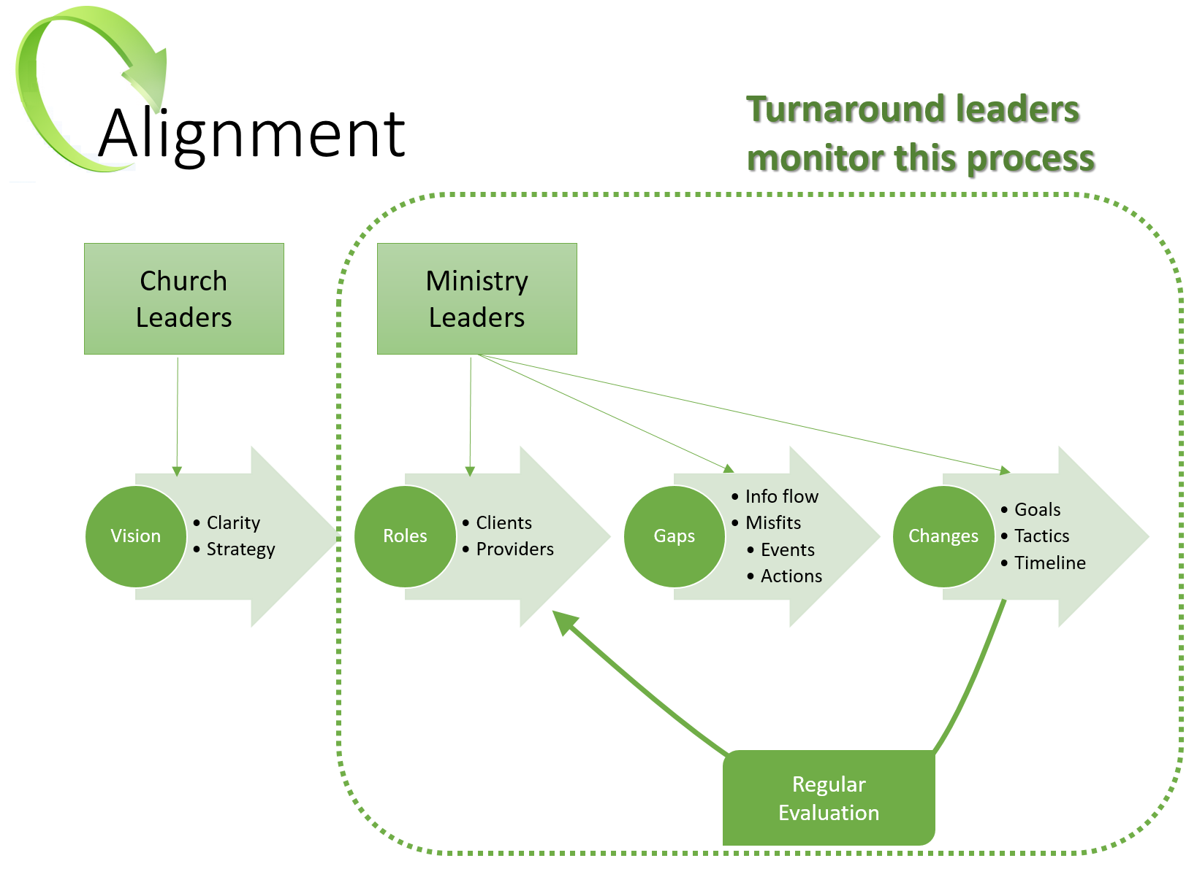
ROLES
- Clients
- Providers
GAPS
- Information Flow
- Misfits
CHANGES
- Goals (include your metrics)
- Tactics
- Timelines
- The process details
  - Create a culture of always asking the Four Alignment Questions:

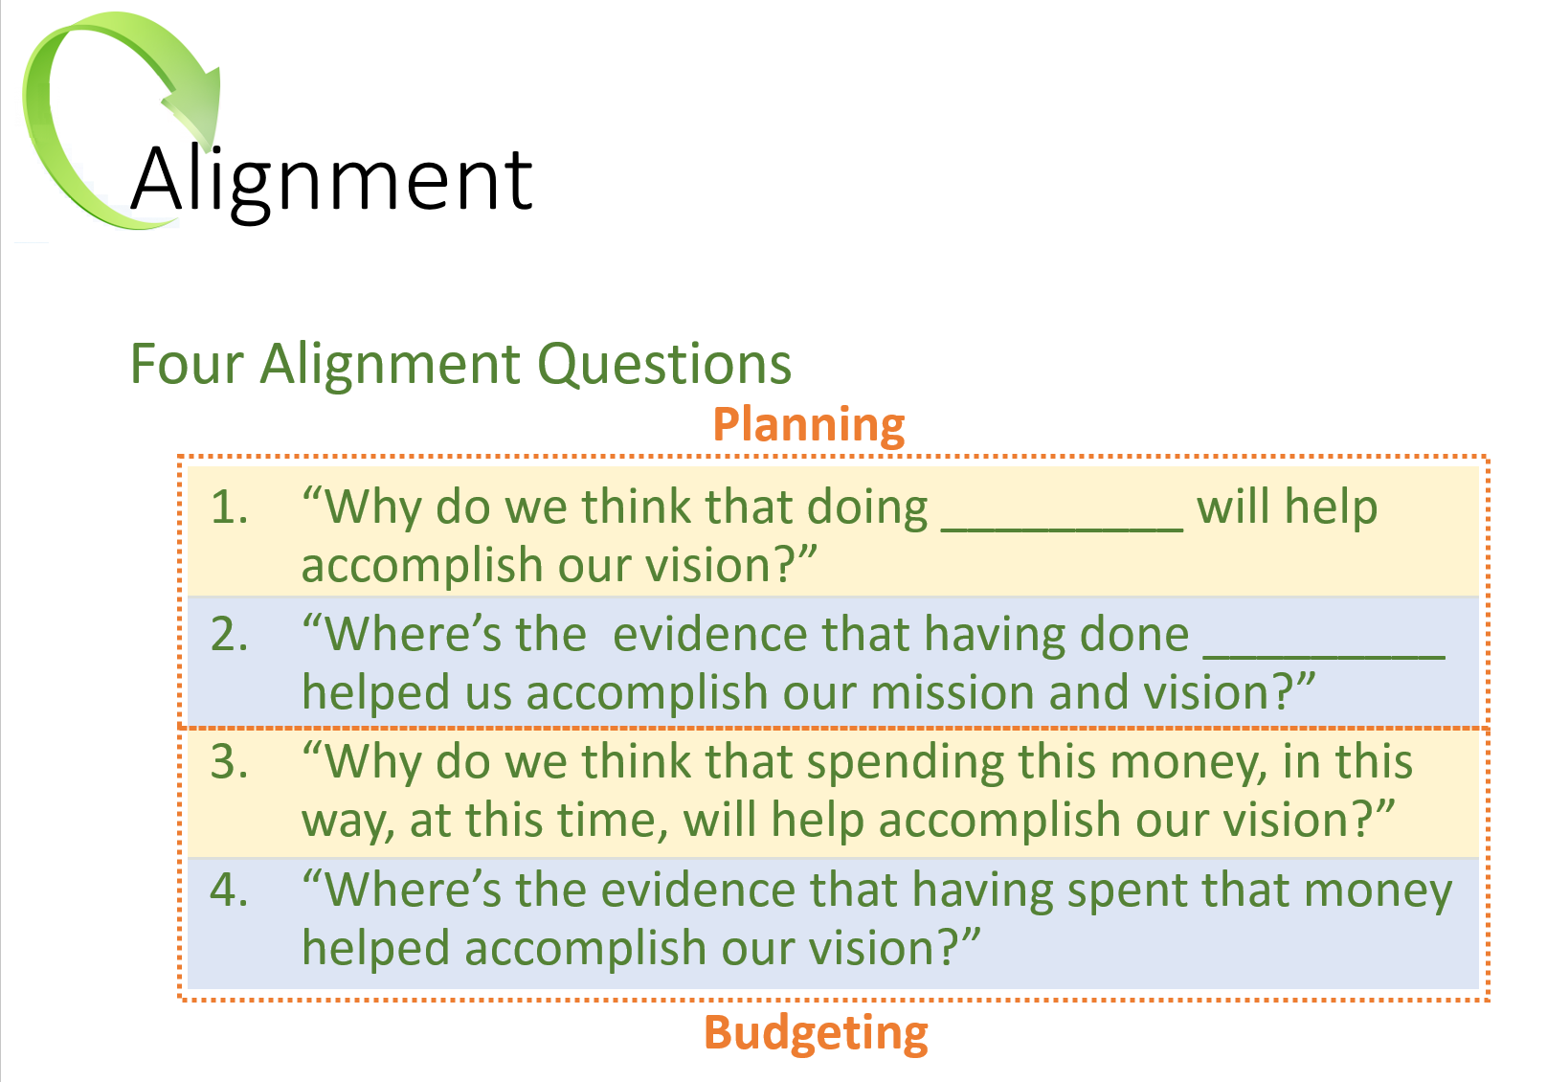
Asking and answering these questions during the planning, debriefing and budgeting phases will help you develop your own set of “best practices.” In time you will accumulate a body of knowledge about what works and what doesn’t.
- “We know that if we do these things, they will lead to accomplishing our vision.”
- “We know that we need to avoid doing those things because either they don’t help us accomplish our vision, or they actually hinder us.
  - Create a culture of evaluating everything the church does:
First, develop metrics that will help you discern whether a ministry, an event, a program or the whole church is making meaningful progress toward the fulfillment of its mission and vision.
Sample Measurements
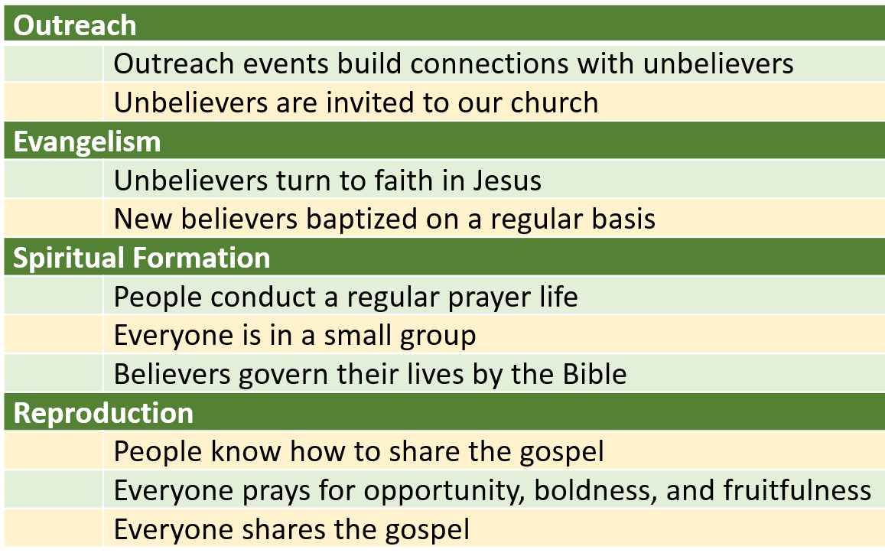
Develop your own concept or matrix for the various broad categories of your church’s ministries, and sketch out a brief description of how each contributes to the mission and the vision. Then, these descriptors will serve as reference points that you (and your team) will use to evaluate the church for alignment.
  - Conduct an audit to identify which components are aligned and which are not.
The details of the audit can become overwhelming, so create a simple system to keep track of everything at a glance. Your system should help you keep track of all the details and also help you avoid becoming lost in them!
In our sample church audit, list the four main ministry areas (outreach, evangelism, spiritual formation, reproduction) across the top of a page and then list every activity your church conducts – whether it is church-wide or confined to a specific segment such as Men’s Ministry or Youth Ministry. Then discuss which of the various major initiatives it supports.
Audit of Events
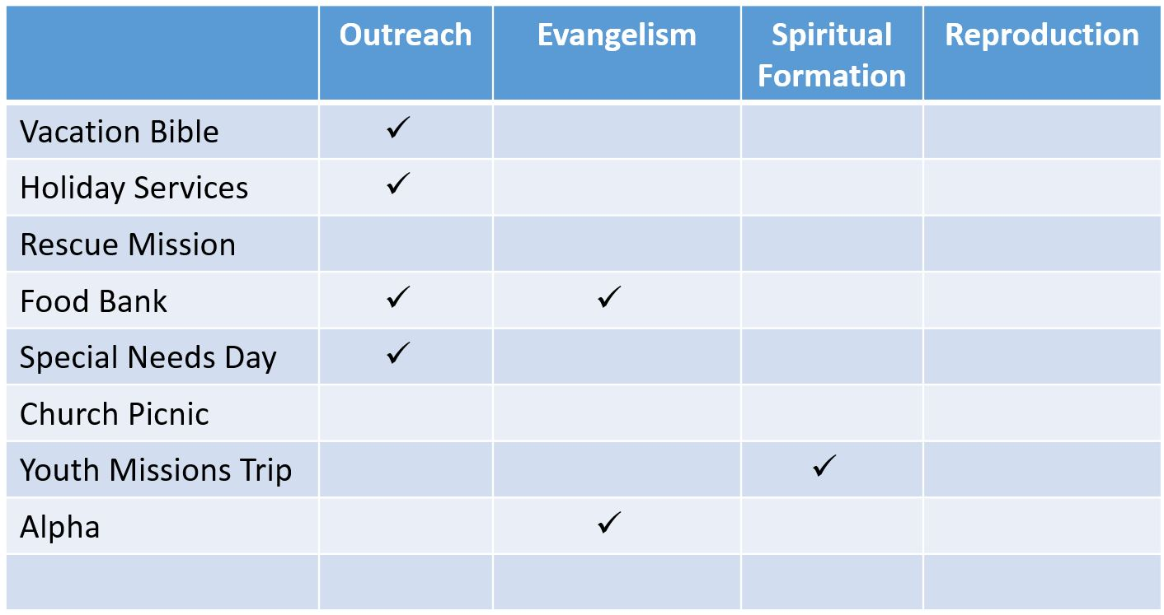
After you’re completed an evaluation of every event in your church, you’ll probably notice that some ministry areas are neglected. In the sample above you’ll notice that nothing really supported the “Reproduction” initiative. You may see that other initiatives are overly weighted, like “Outreach” in our example. And you’ll find events that really don’t contribute to anything (like the Annual Church Picnic!); you’ll need to be careful with some of those! (Example: PVCC float in the annual community parade)
Repeat this process by auditing all of the church’s
- Programs
- Ministries
- Systems
- Expenditures
- Policies and procedures
- External communications (“marketing literature”)
Audit of Ministries
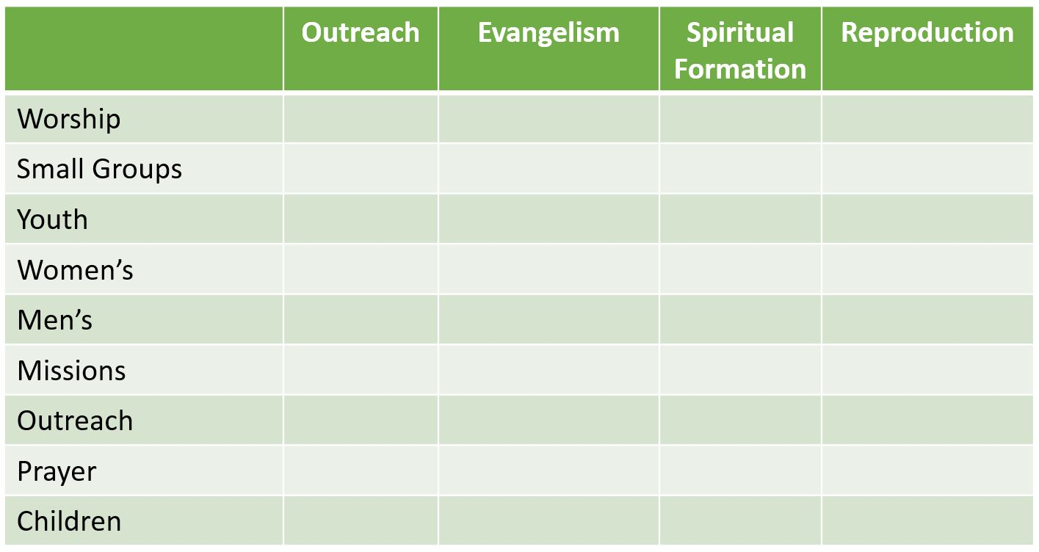
Finally, you should also conduct an audit of staff (paid and unpaid), church officers, and ministry leaders. List them by name and identify their areas of responsibility. If you find out that you don’t have anyone responsible for “Evangelism” per se, you may realize while there’s so little evangelizin’ goin’ on out there!

